LINEAR REGRESSION  Revision Cheat Sheet  1 · WHAT IS LINEAR REGRESSION?  ▪ Supervised learning algorithm used to predict a continuous numerical output.  ▪ Supervised because during training the model sees input x → known output y and learns the relationship between them.  ▪ Simple LR = one input feature; Multiple LR = many input features; Polynomial LR = curved relationship.  ▪ Best Fit Line = the line that represents the data as accurately as possible — errors are as small as possible.  2 · EQUATION OF LINE / PLANE / HYPERPLANE  ▪ In ML we write ŷ = mx + b — m (weight): change in output per 1-unit change in input; b (bias): offset.  Prediction = Effect of Input + Offset  3 · DISTANCE OF A POINT FROM A PLANE  ▪ Plane: Ax+By+Cz+D=0 (A,B,C orient the plane; D fixes its position).  d = |Ax₀+By₀+Cz₀+D| / sqrt(A²+B²+C²)  3B · SIMPLE VS MULTIPLE VS POLYNOMIAL |  |  |  | 4 · FINDING M AND B  Two solution paths  5 · DERIVING OLS (SIMPLE LR)  ▪ Error for point i: dᵢ = yᵢ − ŷᵢ, and ŷᵢ = mxᵢ+b.  ▪ Errors can be negative, so square them:  E(m,b) = Σ (yᵢ − mxᵢ − b)²  ▪ Goal: minimize E over m and b ⇒ set ∂E/∂b = 0 and ∂E/∂m = 0.  ▪ Solving ∂E/∂b=0 gives: b = ȳ − mx̄  6 · FINAL OLS FORMULAS  m = Σ(xᵢ−x̄)(yᵢ−ȳ) / Σ(xᵢ−x̄)²  b = ȳ − m·x̄  ▪ These are exactly what MeraLR.fit() computes from scratch, matching sklearn.LinearRegression.  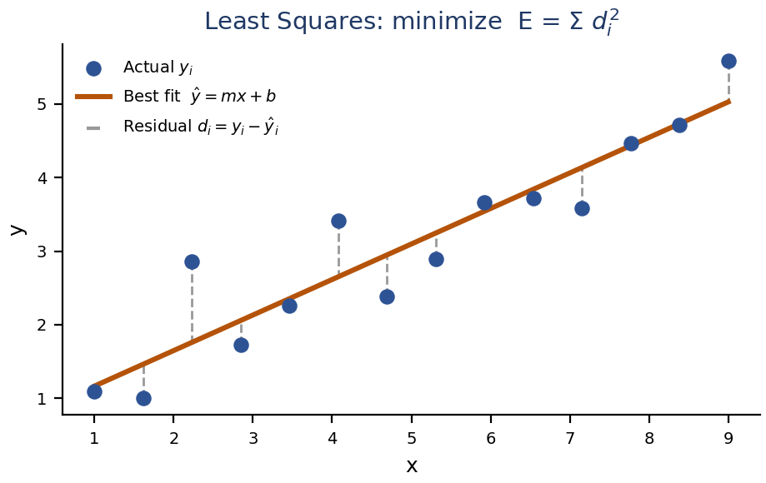  6B · WORKED NUMERIC EXAMPLE (TITANIC-STYLE)  ▪ Placement data: cgpa → package. From scratch fit: m ≈ 0.558, b ≈ −0.896.  Predict for cgpa = 8.58: ŷ = 0.558(8.58) − 0.896 ≈ 3.89  ▪ Matches sklearn's LinearRegression() exactly — OLS has one unique closed-form solution.
  #Features | Geometry | Equation
  1 | Line | ŷ = w₁x₁ + b
  2 | Plane | ŷ = w₁x₁+w₂x₂+b
  3 | Hyperplane (4D) | ŷ = w₁x₁+w₂x₂+w₃x₃+b
  n | Hyperplane | ŷ = w₁x₁+…+wₙxₙ+b
  Type | Inputs | Shape learned
  Simple LR | 1 feature | Straight line
  Multiple LR | 2+ features | Plane / hyperplane
  Polynomial LR | 1+ (with powers) | Curve
  Closed-Form | Non-Closed-Form
  Ordinary Least Squares (OLS) | Gradient Descent
7 · REGRESSION METRICS  ▪ Smaller MAE/MSE/RMSE → better; R² closer to 1 → better.  Example — errors [2,-2,3]: MAE=2.33, MSE=5.67, RMSE=2.38.  8 · R² SCORE (COEFFICIENT OF DETERMINATION)  ▪ Asks: how much variation in the target does my model explain, vs. just predicting the mean?  SST = Σ(yᵢ−ȳ)² SSE = Σ(yᵢ−ŷᵢ)²  R² = 1 − SSE/SST  9 · ADJUSTED R²  ▪ Plain R² never decreases when adding features — even useless ones. Adjusted R² penalizes irrelevant predictors.  Adj. R² = 1 − (1−R²)(n−1)/(n−p−1)  ▪ n = #observations, p = #predictors. Feature helps ⇒ Adj. R² ↑; feature is noise ⇒ Adj. R² ↓.  9B · MAE VS MSE VS RMSE VS R²  ▪ MAE, MSE, RMSE → "How wrong are my predictions?" (error magnitude).  ▪ R², Adjusted R² → "How well does the model explain the target?"  ▪ Rule of thumb: report RMSE for interpretability + R²/Adj. R² for explanatory power. |  |  | 10 · MULTIPLE LINEAR REGRESSION (MLR)  ▪ LR with more than one input feature predicting one continuous target.  ŷ = β₀ + β₁x₁ + β₂x₂ + … + βₙxₙ  ▪ β₀ = intercept/bias; βⱼ = weight of feature xⱼ, learned from training data.  ▪ Comparing β₁ vs β₂ directly is not valid — magnitude depends on each feature's scale/units.  11 · MATRIX (NORMAL EQUATION) FORM  ŷ = Xβ , X has a leading column of 1's (for β₀)  ▪ Minimizing E = (y−Xβ)ᵀ(y−Xβ) and setting ∂E/∂β = 0 gives the closed-form solution:  β = (XᵀX)⁻¹ Xᵀy  ▪ This is exactly what MeraLR (multiple) computes via np.linalg.inv — matches sklearn's coef_/intercept_ exactly.  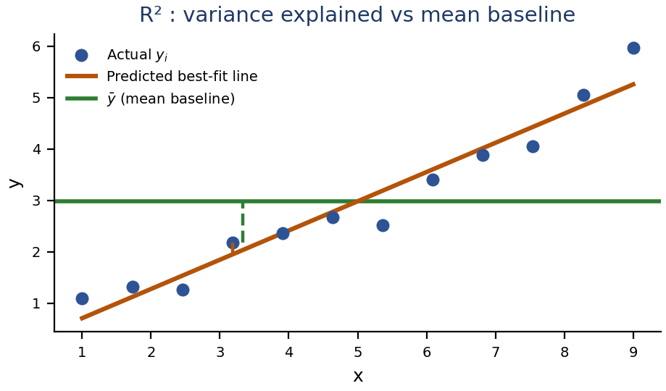  12 · MAIN ASSUMPTIONS OF LR  13 · QUICK FORMULA RECAP
  Metric | Formula | Note
  MAE | (1/n)Σ|yᵢ−ŷᵢ| | Same unit; robust to outliers
  MSE | (1/n)Σ(yᵢ−ŷᵢ)² | Penalizes large errors
  RMSE | √MSE | Same unit; penalizes outliers
  R² | 1 − SSE/SST | Variance explained
  R² value | Meaning
  = 1 | Perfect fit (SSE = 0)
  = 0 | No better than mean baseline
  < 0 | Worse than mean baseline
  Assumption | Simple meaning
  Linear relationship | Inputs & target are linearly related
  No multicollinearity | Predictors aren't highly correlated
  Normal residuals | Errors ≈ normal distribution
  Homoscedasticity | Residual variance stays constant
  No autocorrelation | Errors aren't related to each other
  Concept | Formula
  Simple LR | ŷ = mx + b
  OLS slope | m = Σ(xᵢ−x̄)(yᵢ−ȳ)/Σ(xᵢ−x̄)²
  OLS intercept | b = ȳ − mx̄
  MLR (matrix) | ŷ = Xβ
  Normal equation | β = (XᵀX)⁻¹Xᵀy
  R² | 1 − SSE/SST
  Adjusted R² | 1−(1−R²)(n−1)/(n−p−1)

